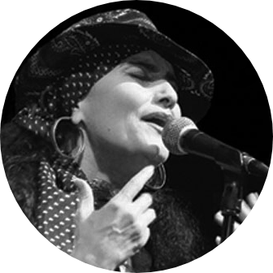

“Chicana Gypsy Project” is a performance group like no other: A sound that crosse cultures from Spain to the United States and music genres from Flamenco to Jazz and beyond. A style that blends the passion of gypsy style Flamenco dance with Jazz standards, Mexican Rancheras and original Flamenco compositions.

Led by renowned Flamenco artist, Maria Bermudez, “Chicana Gypsy Project” evolves from Maria’s roots as a singer and her desire to blend the two worlds in which she lives: the “Cradle of Flamenco”, Jerez de la Frontera, Andalusia, Spain, and Los Angeles, California. This blend of cultures and influences gives “Chicana Gypsy Project” its unique sound, style, and musical approach.

Supported by the power and complexity of Flamenco rhythms, Maria sings in English and Spanish with the sultriness of American Blues and dances with fluidity, and grace and strength.

The musicians that comprise “Chicana Gypsy Project” each brings years of experience in Flamenco, Rock, Jazz, and Latin music to the mix.

With improvisation at the core of its musical approach, “Chicana Gypsy Project” surprises, enchants, and appeals to audiences as diverse as the group itself.

Chicana Gypsy Project

Under the Artistic Direction of Maria Bermudez

Los Angeles, CA/Jerez de la Frontera, Spain