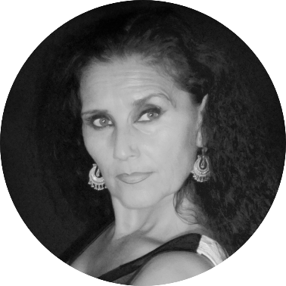

Maria Bermudez is recognized as a Gypsy Flamenco ambassador touring the world with her Company “Sonidos Gitanos”.

Her outstanding and critically acclaimed performances have graced the stages of prominent venues in Spain, North America, and throughout the world, including the Hollywood Bowl and The John Anson Ford Amphitheater in Los Angeles, The Joyce Theatre and Lincoln Center Outdoors in New York, Festival de Beaucaire in France, the Palacio Das Artes, Brazil, and countless festivals. Guest artist appearances such as the Australian Guitar Festival dedicated to Paco de Lucia and with the Santa Cecilia Orchestra’s Sonia de Leon director, The Teatro Villamarta, Spain and most recently, the legendary Fiesta de la Buleria de Jerez as artistic director and performer.

She continues to evolve as an artist with her traditional flamenco company and her Jazz/Flamenco project “Chicana Gypsy.”

Her role as performer and artistic director of the ***“Flamenco! Fiesta de la Buleria – Jerez On Tour”*** debuting at the Walt Disney Concert Hall is a great honor one that Maria aspires to share on stages around the world.

Maria Bermudez

Artistic Director, Dancer

Los Angeles, CA/Jerez de la Frontera, Spain